**Payback% for 100 runs**

**Using random reel layouts each run**

length n NAs unique 0s mean meanCI'

100 100 0 15 0 95.4847 95.2632

100.0% 0.0% 0.0% 95.7062

.05 .10 .25 median .75 .90 .95

93.9525 94.0100 95.1200 96.2500 96.2500 96.2500 96.2500

range sd vcoef mad IQR skew kurt

4.8000 1.1162 0.0117 0.0000 1.1300 -1.3418 1.1493

lowest : 91.45, 92.23, 92.24, 93.15, 93.24

highest: 95.12 (3), 95.13 (4), 95.14 (2), 95.16 (7), 96.25 (61)

heap(?): remarkable frequency (61.0%) for the mode(s) (= 96.25)

' 95%-CI (classic)

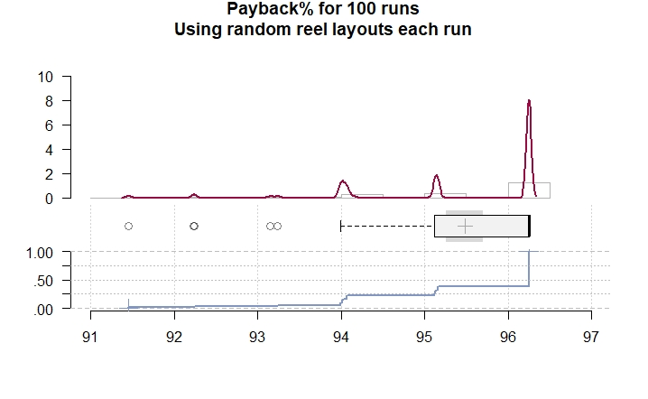

**Hit Frequency for 100 runs**

**Using random reel layouts each run**

length n NAs unique 0s mean meanCI'

100 100 0 26 0 5.0379 5.0088

100.0% 0.0% 0.0% 5.0670

.05 .10 .25 median .75 .90 .95

4.8160 4.8490 4.9575 5.1200 5.1425 5.1500 5.1600

range sd vcoef mad IQR skew kurt

0.6700 0.1465 0.0291 0.0445 0.1850 -1.3419 1.3256

lowest : 4.49, 4.61, 4.62, 4.74 (2), 4.82

highest: 5.12 (3), 5.13 (7), 5.14 (17), 5.15 (16), 5.16 (9)

heap(?): remarkable frequency (17.0%) for the mode(s) (= 5.14)

' 95%-CI (classic)

